**Microprocessor Systems & Interfacing Lab**

**Project Proposal**



**“Digital Code Lock”**

Fall 2016

**Submitted By:**

Waleed Niaz FA16-BEE-054

**Supervisor:**

“Engr. Zubair Khaliq”

Department of Electrical Engineering

COMSATS Institute of Information Technology

Wah Campus

1. **Introduction:**

Security is a major concern in our day to day life, and **Digital Locks**have become an important part of these security systems. There are many types of technologies available for security purpose but our purpose is to provide a digitally password based security system with keypad using [**Arduino Uno**](https://electrosome.com/arduino-uno/)**.** It will open your door only when the right password is entered and it will start beeping when a wrong password is entered.

**2. Project Aim:**

The aim of the project of “Arduino based password protected locking system” can be used to provide enough security in various places like bank lockers, security doors, BIOS locking in computer etc.

**3. Hardware:**

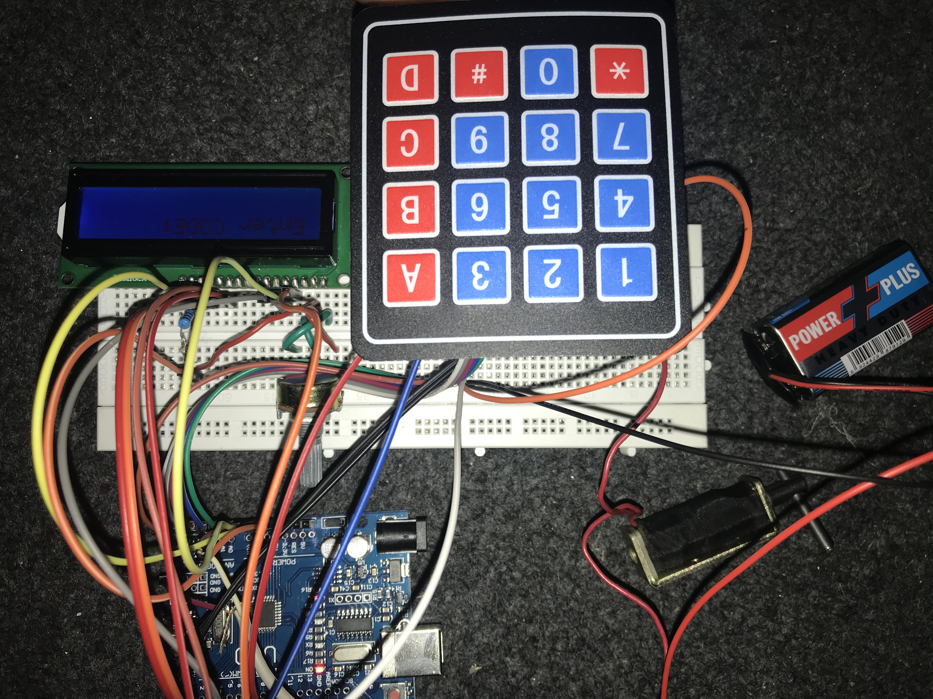

**4. Future Work & Conclusion:**

This project is effective in providing enough security as long as the password is not shared. In future this “Arduino based password security locking system” can be provided maximum security by the above enhancements in order to completely satisfy user’s needs. Hence, a common man can afford to purchase such locking system in minimal cost to keep his valuables safely without any worries.

**5. References:**

[1]. Arduino Programming Notebook – Brian W Evans , First edition, Aug 2007

[2]. <http://arduino.cc/tutorial>

[3]. http://instructables.com

[4]. Getting started with Arduino, Mazzimo Banzi(cofounder), 2nd edition 2011, O’Reilly

[5]. Arduino Micro-controller Guide, W. Durfee, University of Minnesota, Ver-2011

**6. Source Code:**

*#include <Keypad.h>*

*#include<LiquidCrystal.h>*

*#include<EEPROM.h>*

*LiquidCrystal lcd(9,8,7,6,5,4);*

*char password[4];*

*char pass[4],pass1[4];*

*int i=0;*

*char customKey=0;*

*const byte ROWS = 4; //four rows*

*const byte COLS = 4; //four columns*

*char hexaKeys[ROWS][COLS] = {*

*{'1','2','3','A'},*

*{'4','5','6','B'},*

*{'7','8','9','C'},*

*{'*','0','#','D'}*

*};*

*byte rowPins[ROWS] = {A0,A1,A2,A3}; //connect to the row pinouts of the keypad*

*byte colPins[COLS] = {A4,A5,3,2}; //connect to the column pinouts of the keypad*

*//initialize an instance of class NewKeypad*

*Keypad customKeypad = Keypad( makeKeymap(hexaKeys), rowPins, colPins, ROWS, COLS);*

*int led;*

*int buzzer = 10;*

*int m11;*

*int m12;*

*void setup()*

*{*

*Serial.begin(9600);*

*pinMode(11, OUTPUT);*

*lcd.begin(16,2);*

*pinMode(led, OUTPUT);*

*pinMode(buzzer, OUTPUT);*

*pinMode(m11, OUTPUT);*

*pinMode(m12, OUTPUT);*

*lcd.print(" Electronic ");*

*Serial.print(" Electronic ");*

*lcd.setCursor(0,1);*

*lcd.print(" Keypad Lock ");*

*Serial.print(" Keypad Lock ");*

*delay(2000);*

*lcd.clear();*

*lcd.print("Enter Ur Passkey:");*

*Serial.println("Enter Ur Passkey:");*

*lcd.setCursor(0,1);*

*for(int j=0;j<4;j++)*

*EEPROM.write(j, j+49);*

*for(int j=0;j<4;j++)*

*pass[j]=EEPROM.read(j);*

*}*

*void loop()*

*{*

*digitalWrite(11, HIGH);*

*customKey = customKeypad.getKey();*

*if(customKey=='#')*

*change();*

*if (customKey)*

*{*

*password[i++]=customKey;*

*lcd.print(customKey);*

*Serial.print(customKey);*

*beep();*

*}*

*if(i==4)*

*{*

*delay(200);*

*for(int j=0;j<4;j++)*

*pass[j]=EEPROM.read(j);*

*if(!(strncmp(password, pass,4)))*

*{*

*digitalWrite(led, HIGH);*

*beep();*

*lcd.clear();*

*lcd.print("Passkey Accepted");*

*Serial.println("Passkey Accepted");*

*digitalWrite(11, LOW);*

*delay(2000);*

*lcd.setCursor(0,1);*

*lcd.print("#.Change Passkey");*

*Serial.println("#.Change Passkey");*

*delay(2000);*

*lcd.clear();*

*lcd.print("Enter Passkey:");*

*Serial.println("Enter Passkey:");*

*lcd.setCursor(0,1);*

*i=0;*

*digitalWrite(led, LOW);*

*}*

*else*

*{*

*digitalWrite(11, HIGH);*

*digitalWrite(buzzer, HIGH);*

*lcd.clear();*

*lcd.print("Access Denied...");*

*Serial.println("Access Denied...");*

*lcd.setCursor(0,1);*

*lcd.print("#.Change Passkey");*

*Serial.println("#.Change Passkey");*

*delay(2000);*

*lcd.clear();*

*lcd.print("Enter Passkey:");*

*Serial.println("Enter Passkey:");*

*lcd.setCursor(0,1);*

*i=0;*

*digitalWrite(buzzer, LOW);*

*}*

*}*

*}*

*void change()*

7. Schematic Diagram:

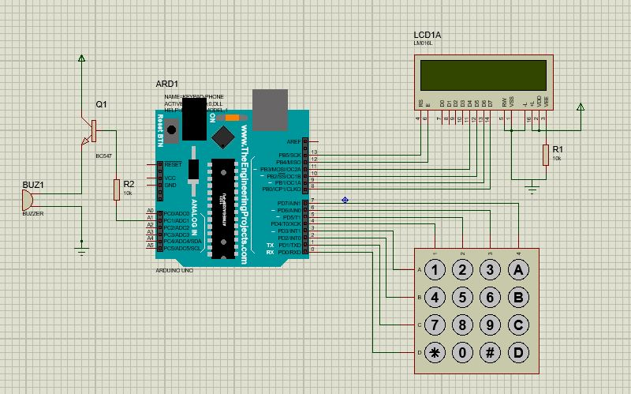

8. List of Equipment’s

* 4×4 keypad
* [LCD](https://electrosome.com/lcd-display-fundamentals/)
* [Arduino Uno](https://electrosome.com/arduino-uno/)
* Push Pull Solenoid
* TIP 120 NPN transistor
* Power Supply
* Breadboard
* 1KΩ, 220Ω Resistor
* 10KΩ Potentiometer
* Buzzer
* Connecting wires